 | Experiment Title: Write a program to demonstrate different number data types in Python.
 | Laboratory: PYTHON LAB
Experiment No: 1 | Department: | Semester:

PROGRAM
a = 5
b = 3.14
c = 6 + 3j
d = "Hello! This is pyhon program"
e = ['python', 'php', 'javascript']
print(type(a))
print(type(b))
print(type(c))
print(type(d))
print(type(e))

OUTPUT
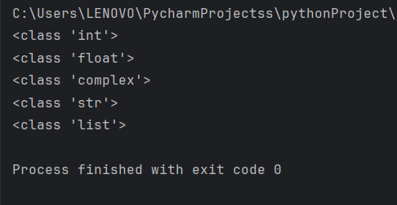

 | Experiment Title: Write a program to perform different Arithmetic Operations on numbers in Python.
 | Laboratory: PYTHON LAB
Experiment No: 2 | Department: | Semester:

PROGRAM
# By Assigning input :
a = 100
b = 5
print('Sum: ', a + b)
print('Subtraction: ', a - b)
print('Multiplication: ', a * b)
print('Division: ', a / b)
print('Modulo: ', a % b)
print('Power: ', a ** b)

OUTPUT
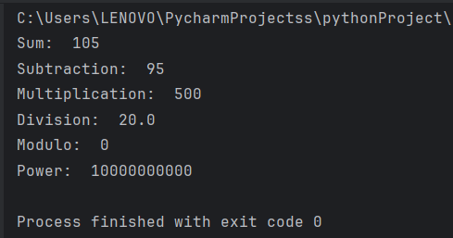

PROGRAM
# By taking input from user :
num1 = int(input("Enter Your 1st Number"))
num2 = int(input("Enter Your 2nd Number"))
print('Sum: ', num1 + num2)
print('Subtraction: ', num1 - num2)
print('Multiplication: ', num1 * num2)
print('Division: ', num1 / num2)
print('Modulo: ', num1 % num2)
print('Power: ', num1 ** num2)

OUTPUT
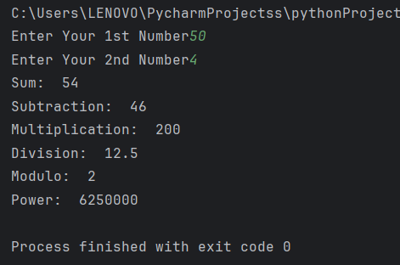


 | Experiment Title: Write a program to create, concatenate and print a string and accessing sub-string from a given string.
 | Laboratory: PYTHON LAB
Experiment No: 3 | Department: | Semester:

PROGRAM
#create a string
string1= "INDIAN"
string2= "INSTITUTE "
string3= "OF"
string4= "TECHNOLOGY"
#concatenate a string
string= string1+" " +string2+" " +string3+" " +string4
#print a string
print(string)
#accessing a substring
substring= string[3:17]
print(substring)

OUTPUT
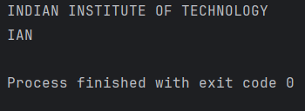

 | Experiment Title: Write a python script to print the current date in the following format “Sun May 29 02:26:23 IST 2017”
 | Laboratory: PYTHON LAB
Experiment No: 4 | Department: | Semester:

PROGRAM
import time
currenttime = time.strftime("%a %b %d %H:%M:%S IST %Y")
print(currenttime)

OUTPUT
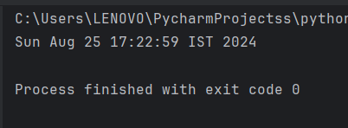

 | Experiment Title: Write a program to create, append, and remove lists in python.
 | Laboratory: PYTHON LAB
Experiment No: 5 | Department: | Semester:

PROGRAM
#Create a List
List1=["C","C++","C#","Python","Java","Javascript"]
#print a list
print(List1)
#Append a list
List1.append("Java")
print(List1)
#Remove from List
List1.remove("C#")
print(List1)

OUTPUT
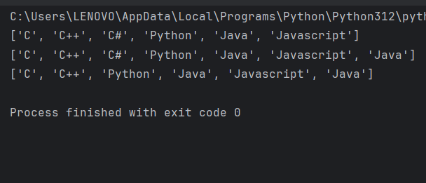

 | Experiment Title: Write a program to demonstrate working with tuples in python.
 | Laboratory: PYTHON LAB
Experiment No: 6 | Department: | Semester:

PROGRAM
#Create a tuples
TupleMNC1=("Google","Meta","Microsoft","IBM","Oracle","SAP")
TupleMNC2=("Cisco","Crowdstrike","Palo Alto Network","Fortinet","Rapid7")
TupleMNC3=("Samsung", "Amazon", "HP", "Alphabet")
#Accessing a tuples
print(TupleMNC1)
print(TupleMNC2)
print(TupleMNC3)
#accessing tuples with indexing
print("Indexing1 :" ,TupleMNC1[-2])
print("Indexing2 :" ,TupleMNC2[1])
print("Indexing3 :" ,TupleMNC3[3])
#Slicing of tuples
print("sliced tuple1 : ", TupleMNC1[1:-2])
print("sliced tuple2 : ", TupleMNC2[0:3])
print("sliced tuple3 : ", TupleMNC3[1:3])
#Length of tuples
print("Length of tuple1 : ", len(TupleMNC1))
print("Length of tuple2 : ", len(TupleMNC2))
print("Length of tuple3 : ", len(TupleMNC3))
#Deleting a tuple
del(TupleMNC3);
#Concatenating a tuples
print("TupleWorldsMNC : ", TupleMNC1+TupleMNC2)
OUTPUT
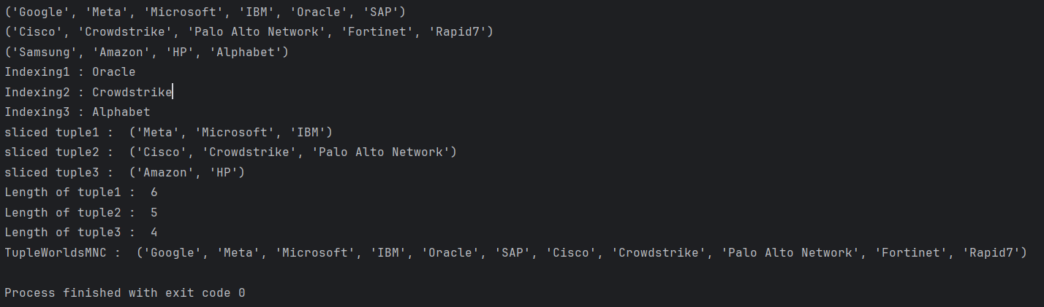

 | Experiment Title: Write a program to demonstrate working with dictionaries in python.
 | Laboratory: PYTHON LAB
Experiment No: 7 | Department: | Semester:

PROGRAM
#Creating a dictionary
DictionaryPython = {
"List":"A list is an ordered and changeable,collection ",
"Set" :"A set is an unordered and unchangeable,collection ",
}
print("Python values : ")
for key, value in DictionaryPython.items():
print(f"{key}:{value}")
#Accessing values in dictionary
Choice= str(input("Accessing individual values : "))
print(DictionaryPython[Choice])
#Accessing key values
print("Accessing Keys : ",list(DictionaryPython.keys()))
#Updating a dictionary
DictionaryPython["Python"]="Python is an programing language"
print(DictionaryPython)
#Poping a kay values
DictionaryPython.pop("Python")
print(DictionaryPython)

OUTPUT
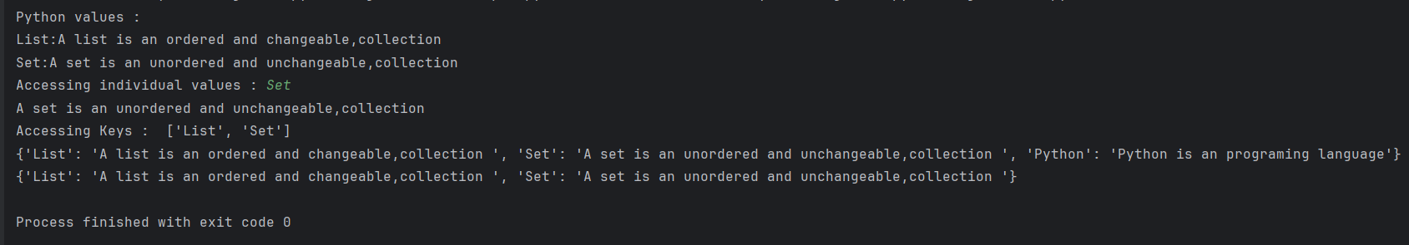

 | Experiment Title: Write a python program to find largest of three numbers.
 | Laboratory: PYTHON LAB
Experiment No: 8 | Department: | Semester:

PROGRAM
Number1=int(input("Enter Number1 : "))
Number2=int(input("Enter Number2 : "))
Number3=int(input("Enter Number3 : "))
if (Number1>Number2 ) and (Number1>Number3):
Largest=Number1
print("The Largest Number is ", Largest)
elif (Number2>Number1 ) and (Number2>Number3):
Largest=Number2
print("The Largest Number is ", Largest)
else:
Largest=Number3
print("The Largest Number is ", Largest)

OUTPUT
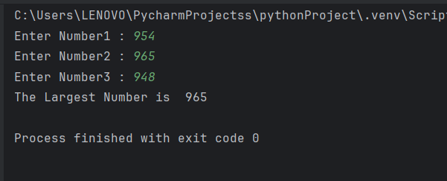

 | Experiment Title: Write a Python program to convert temperatures to and from Celsius, Fahrenheit. [ Formula: c/5 = f-32/9].
 | Laboratory: PYTHON LAB
Experiment No: 9 | Department: | Semester:

PROGRAM
def celsius_to_fahrenheit(c):
# find temperature in Fahrenheit
f = (c * 9)/5 + 32
return f

def fahrenheit_to_celsius(f):
# find temperature in Celsius
c = (f - 32) * 5 / 9
return c

print("Enter a temperature value:")
temperature = float(input())

# Assuming the input temperature is in Celsius and converting it to Fahrenheit
fahrenheit = celsius_to_fahrenheit(temperature)
print(f"{temperature}°C is {fahrenheit}°F")

# Assuming the input temperature is in Fahrenheit and converting it to Celsius
celsius = fahrenheit_to_celsius(temperature)
print(f"{temperature}°F is {celsius:.2f}°C")

OUTPUT
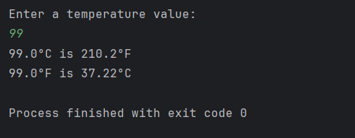

 | Experiment Title: Write a Python program to construct the following pattern, using a nested for loop.
 | Laboratory: PYTHON LAB
Experiment No: 10 | Department: | Semester:

PROGRAM
n = 5

# Upper part of the pattern
for i in range(1, n + 1):
for j in range(i):
print("*", end=" ")
print()

# Lower part of the pattern
for i in range(n - 1, 0, -1):
for j in range(i):
print("*", end=" ")
print()

OUTPUT
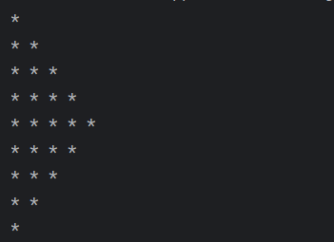

 | Experiment Title: Write a Python script that prints prime numbers less than 20.
 | Laboratory: PYTHON LAB
Experiment No: 11 | Department: | Semester:

PROGRAM

def is_prime(n):
if n <= 1:
return False
for i in range(2, int(n**0.5) + 1):
if n % i == 0:
return False
return True

for num in range(20):
if is_prime(num):
print(num)

OUTPUT
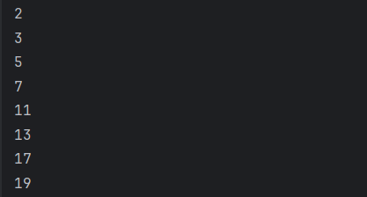
 | Experiment Title: Write a python program to find factorial of a number using Recursion.
 | Laboratory: PYTHON LAB
Experiment No: 12 | Department: | Semester:

PROGRAM
def factorial(n):
if n==0 or n==1:
return n
else:
return n * factorial(n-1)
print("Enter a number whose factorial is o be performed : ")
Number= int(input())
if Number<0:
print("Factorial not possible ")
else:
print("Factorial of", Number, "is", factorial(Number))

OUTPUT
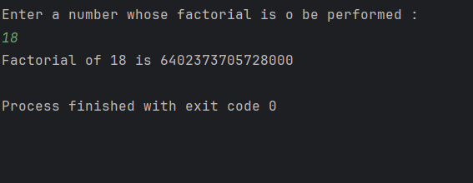

 | Experiment Title: Write a program that accepts the lengths of three sides of a triangle as inputs. The program output should indicate whether or not the triangle is a right triangle.
 | Laboratory: PYTHON LAB
Experiment No: 13 | Department: | Semester:

PROGRAM
print("Enter the length of Hypotenuse : ")
Hypotenuse=int(input())
print("Enter the length of Perpendicular : ")
Perpendicular =int(input())
print("Enter the length of Base : ")
Base=int(input())
print("To check whether the triangle is a right triangle or not")
if Hypotenuse**2 = = Perpendicular**2 + Base**2:
print("It is a Right Triangle")
else:
print("It is not a Right Triangle")

OUTPUT
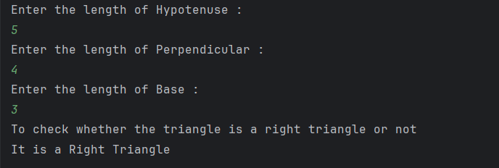
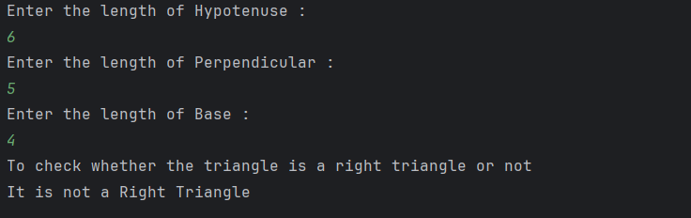
 | Experiment Title: Write a python program to define a module to find Fibonacci Numbers and import the module to another program.
 | Laboratory: PYTHON LAB
Experiment No: 14 | Department: | Semester:

PROGRAM
# Fibonacci numbers module
def fib(n): # write Fibonacci series up to n
a, b = 0, 1
while b < n:
print(b, end =" ")
a, b = b, a+b

#import fibonacci module
import fibonaccimodule
num=int(input("Enter any number to print Fibonacci series "))
fibonaccimodule.fib(num)

OUTPUT
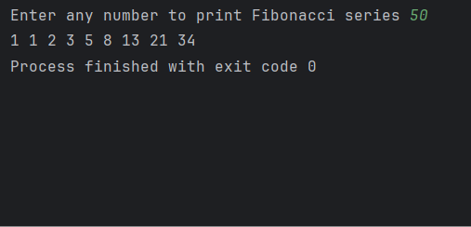

 | Experiment Title: Write a python program to define a module and import a specific function in that module to another program.
 | Laboratory: PYTHON LAB
Experiment No: 15 | Department: | Semester:

PROGRAM

Arithmetic Operations Module with Multiple functions
def Addition(a,b):
c=a+b
return c
def Subtraction(a,b):
c=a-b
return c
def Multiplication(a,b):
c=a*b
return c
def Power(a,b):
c=a**b
return c
def Division(a,b):
c=a/b
return c
def Modulo(a,b):
c=a%b
return c
importing specific function from module
from Arithmetic import Addition
from Arithmetic import Subtraction
num1=float(input("Enter first Number : "))
num2=float(input("Enter second Number : "))
print("Addition is : ",Addition(num1,num2))
print("Subtraction is : ",Subtraction(num1,num2))

OUTPUT
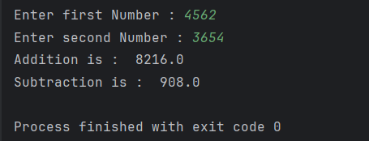

 | Experiment Title: Write a script named copyfile.py. This script should prompt the user for the names of two text files. The contents of the first file should be input and written to the second file.
 | Laboratory: PYTHON LAB
Experiment No: 16 | Department: | Semester:

PROGRAM
file1 = input("Enter First Filename : ")
file2 = input("Enter Second Filename : ")
# open file in read mode
fn1 = open(file1, 'r')
# open other file in write mode
fn2 = open(file2, 'w')
# read the content of the file line by line
cont = fn1.readlines()
# type(cont)
for i in range(0, len(cont)):
fn2.write(cont[i])
# close the file
fn2.close()
print("Content of first file copied to second file ")
# open file in read mode
fn2 = open(file2, 'r')
# read the content of the file
cont1 = fn2.read()
# print the content of the file
print("Content of Second file :")
print(cont1)
# close all files
fn1.close()
fn2.close()
OUTPUT
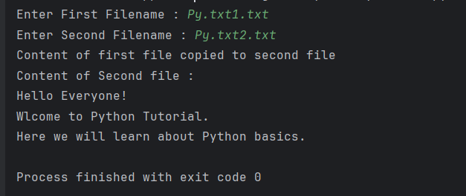
 | Experiment Title: Write a program that inputs a text file. The program should print all of the unique words in the file in alphabetical order.
 | Laboratory: PYTHON LAB
Experiment No: 17 | Department: | Semester:

PROGRAM
fname = input("Enter file name: ")
fh = open(fname)
lst = list()
words=[];
for line in fh:
words += line.split()
words.sort()
# display the sorted words
print("The unique words in alphabetical order are:")
for word in words:
if word in lst:
continue
else:
lst.append(word)
print(word)

OUTPUT
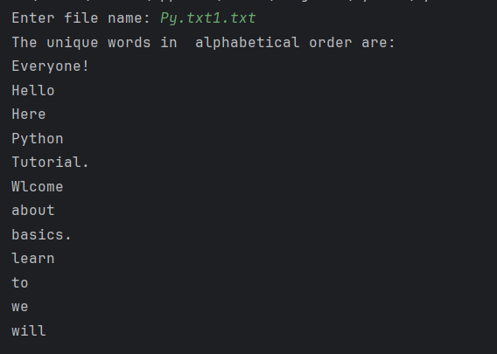
 | Experiment Title: Write a Python class to convert an integer to a roman numeral.
 | Laboratory: PYTHON LAB
Experiment No: 18 | Department: | Semester:

PROGRAM
class irconvert:
num_map = [(1000, 'M'), (900, 'CM'), (500, 'D'), (400, 'CD'), (100, 'C'), (90, 'XC'), (50, 'L'), (40, 'XL'),
(10, 'X'), (9, 'IX'), (5, 'V'), (4, 'IV'), (1, 'I')]
def num2roman(self, num):
roman = ''
while num > 0:
for i, r in self.num_map:
while num >= i:
roman += r
num -= i
return roman
num = int(input("Enter any Number :"))
print("Roman Number is : ", irconvert().num2roman(num))

OUTPUT
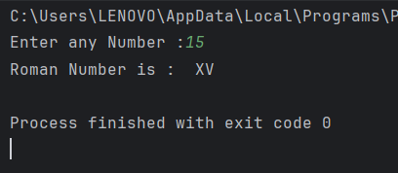

 | Experiment Title: Write a Python class to implement pow(x, n).
 | Laboratory: PYTHON LAB
Experiment No: 19 | Department: | Semester:

PROGRAM
class py_pow:
def powr(self, x, n):
if x==0 or x==1 or n==1:
return x
if x==-1:
if n%2 ==0:
return 1
else:
return -1
if n==0:
return 1
if n<0:
return 1/self.powr(x,-n)
val = self.powr(x,n//2)
if n%2 ==0:
return val*val
return val*val*x
x=int(input("Enter x value :"))
n=int(input("Enter n value :"))
print("pow(x,n) value is :",py_pow().powr(x,n));

OUTPUT
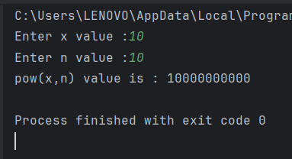
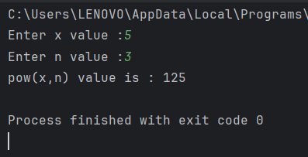

 | Experiment Title: Write a Python class to reverse a string word by word.
 | Laboratory: PYTHON LAB
Experiment No: 20 | Department: | Semester:

PROGRAM
class py_reverse:
def revr(self, strs):
sp=strs.split()
sp.reverse()
res=" ".join(sp)
return res
str1=input("Enter a string with 2 or more words : ")
print("Reverse of string word by word: \n",py_reverse().revr(str1));

OUTPUT
